**Analysis Class Diagram**

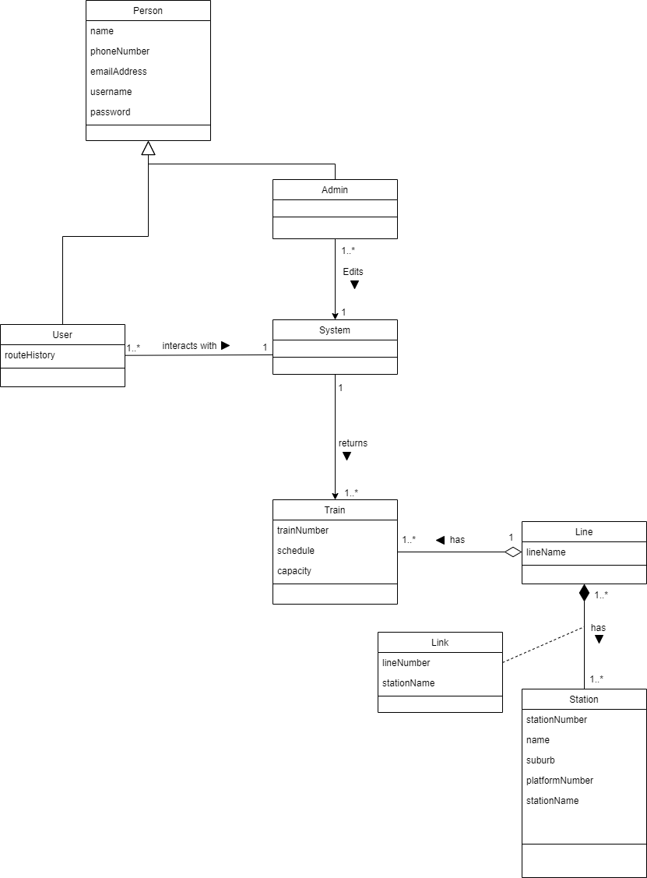

There are only a few railway lines which all include several stations. Some of these stations may be apart of more than one line – this is where a transfer could occur. Each line also has a few trains which run daily on specific schedules. Users interact with the web interface (system) by inputting the required information, as well as optional additional information. The interface will then calculate the shortest route between two stations and return a list of trains (with times) which achieve this shortest route. Admins can edit the train schedules through the system.